**Practical No.11**

* **Create a JSON file and import it to MongoDB**

**A] Import:**

**1] Start mongodb**

**2] Start mongo**

**3] Create stud.json file**

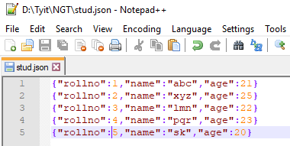

**4] Open command prompt run as administrator and write following command**

C:\Users\shree>mongoimport --db college --collection student --type json --file D:\Tyit\NGT\stud.json



**5] Open mongo command prompt and check data is inserted or not.**

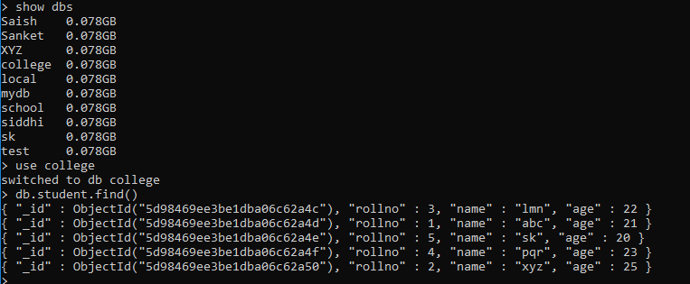

**B] Export:**

**1] Start mongodb**

**2] Start mongo**

**3] Open command prompt run as administrator and write following command**

C:\Users\shree>mongoexport --db college --collection student --type json --out D:\Tyit\NGT\stud.json



Q.B] Write a MongoDB query to delete JSON object from MongoDB

